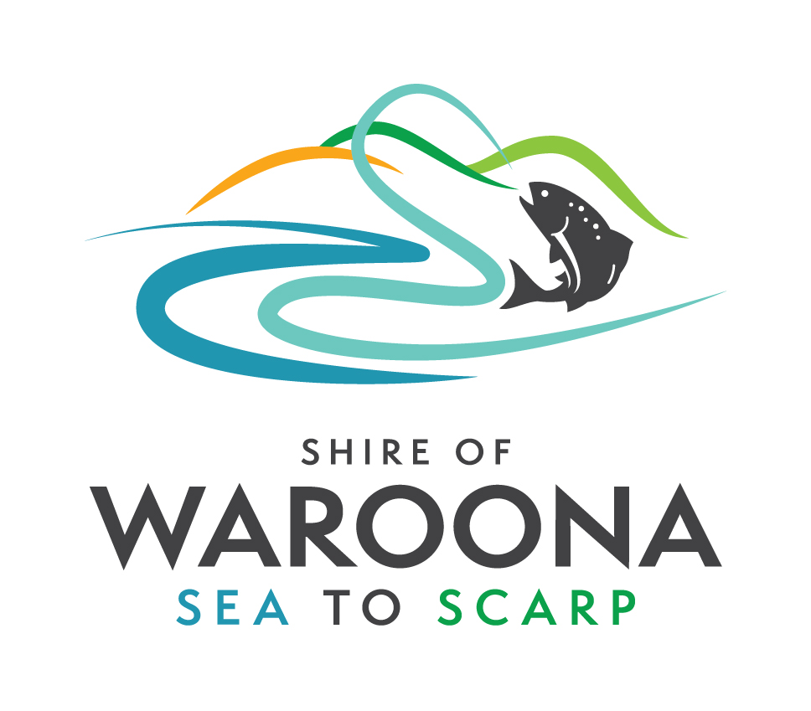

SHIRE OF WAROONA

NOTICE OF SPECIAL COUNCIL MEETING

A Special Meeting of the Council will be held on Thursday 19 August, 2021 commencing at 5.00 pm in the Council Chambers to deliberate on the following matters –

- CEO Recruitment Panel – Terms of Reference 2021
- CEO Recruitment Panel – Confidentiality Agreement 2021
- CEO Recruitment 2021 – Position Description
- Confidential Item - CEO Recruitment 2021 – Employment Contract

DEAN UNSWORTH
CHIEF EXECUTIVE OFFICER

